Grand Champion and Reserve Grand Champion Steer
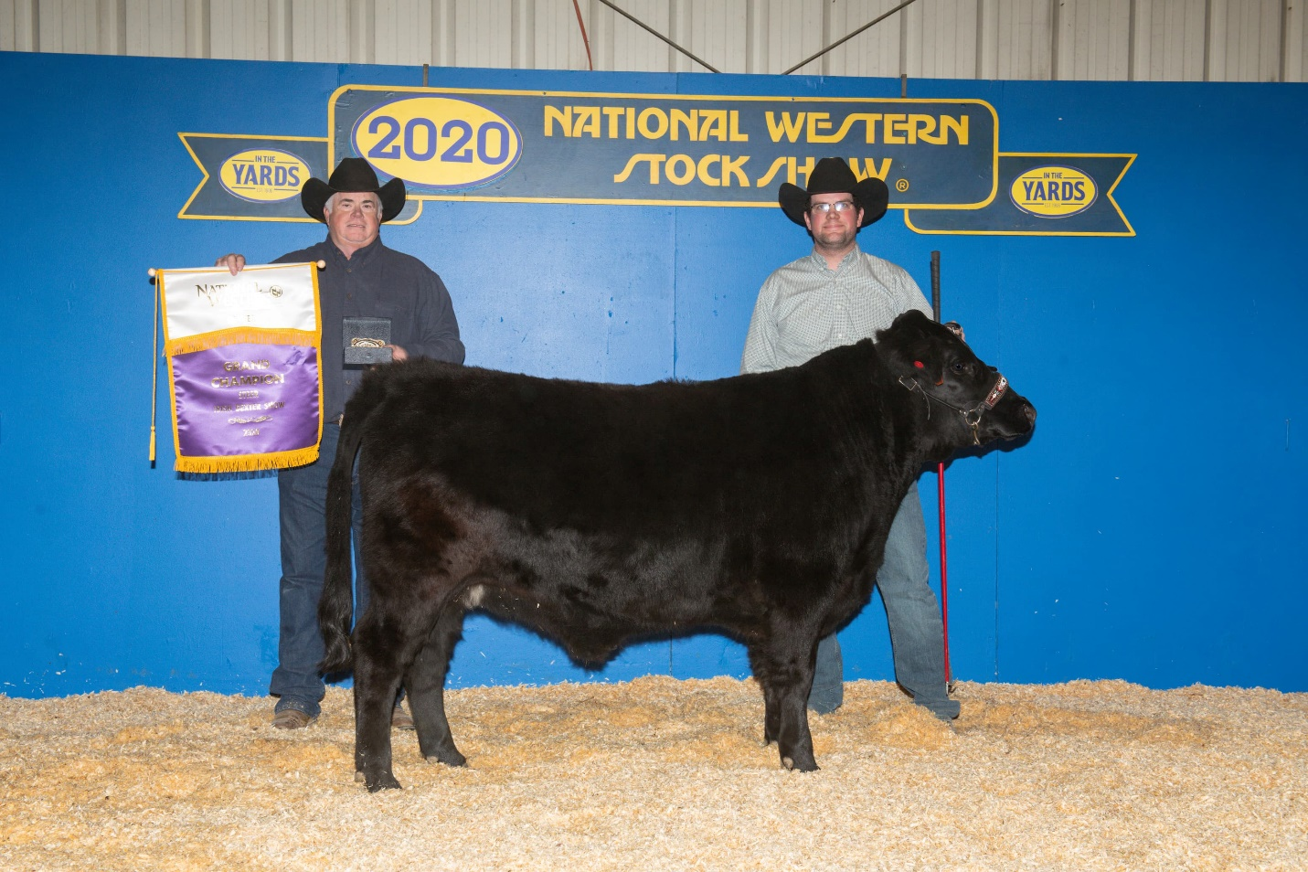
Place | Back# | Animal Name | Owner | Exhibitor
1st | 6527 | BW T-Rex | Weston Berry - BW Dexters of Lehi, UT | Weston Berry - BW Dexters of Lehi, UT
2nd | 6526 | Elemental Cayenne | Tanya Garcia - Elemental Family Farm of Renton, WA | Tanya Garcia - Elemental Family Farm of Renton, WA

Grand and Reserve Grand Champion Female
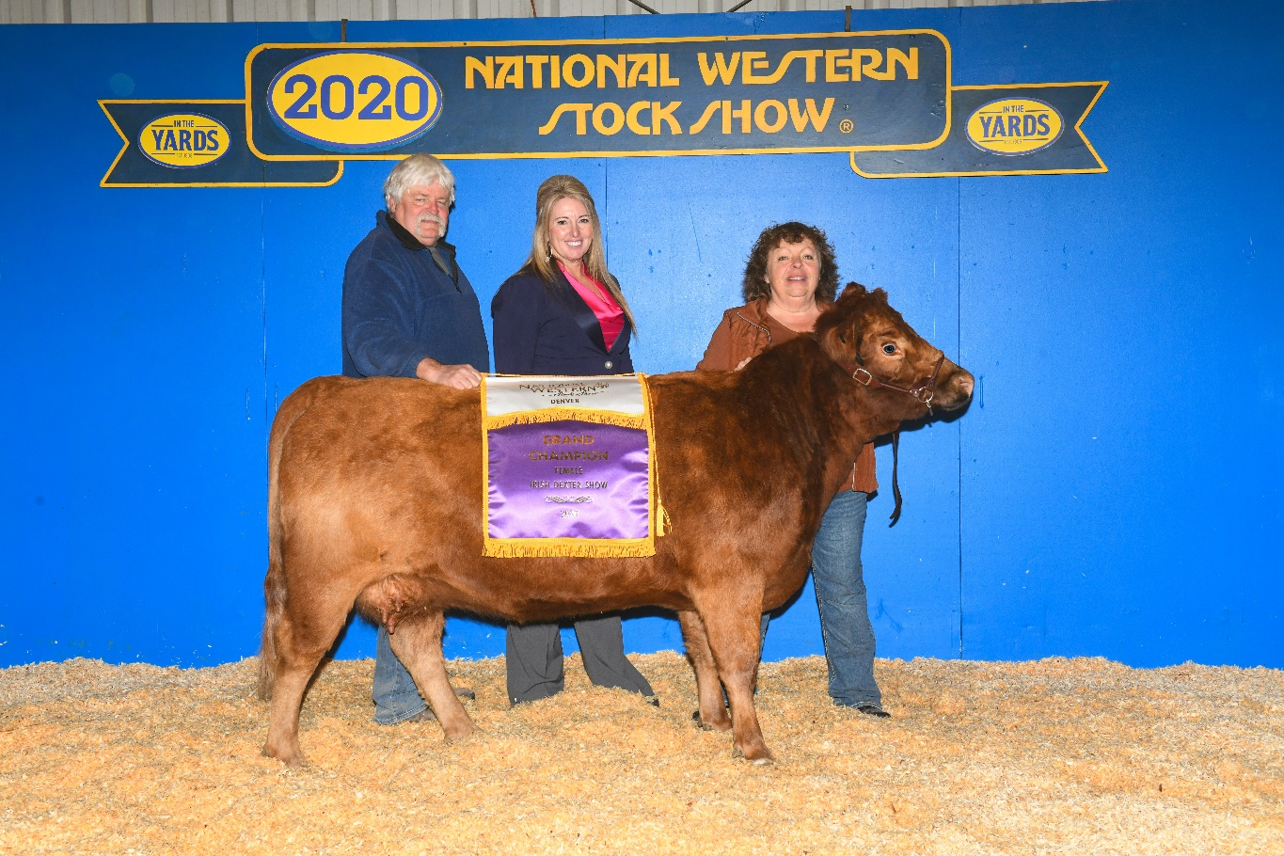
Place | Back# | Animal Name | Owner | Exhibitor
1st | 6511 | Sprague's Janell | Moosters Meadows of Lusk, WY | - Moosters Meadows of Lusk, WY
2nd | 6503 | Circle B Fancy One | Bill Bartolac - Circle B Angus of Kittitas, WA | Bill Bartolac - Circle B Angus of Kittitas, WA

Grand and Reserve Grand Champion Bull
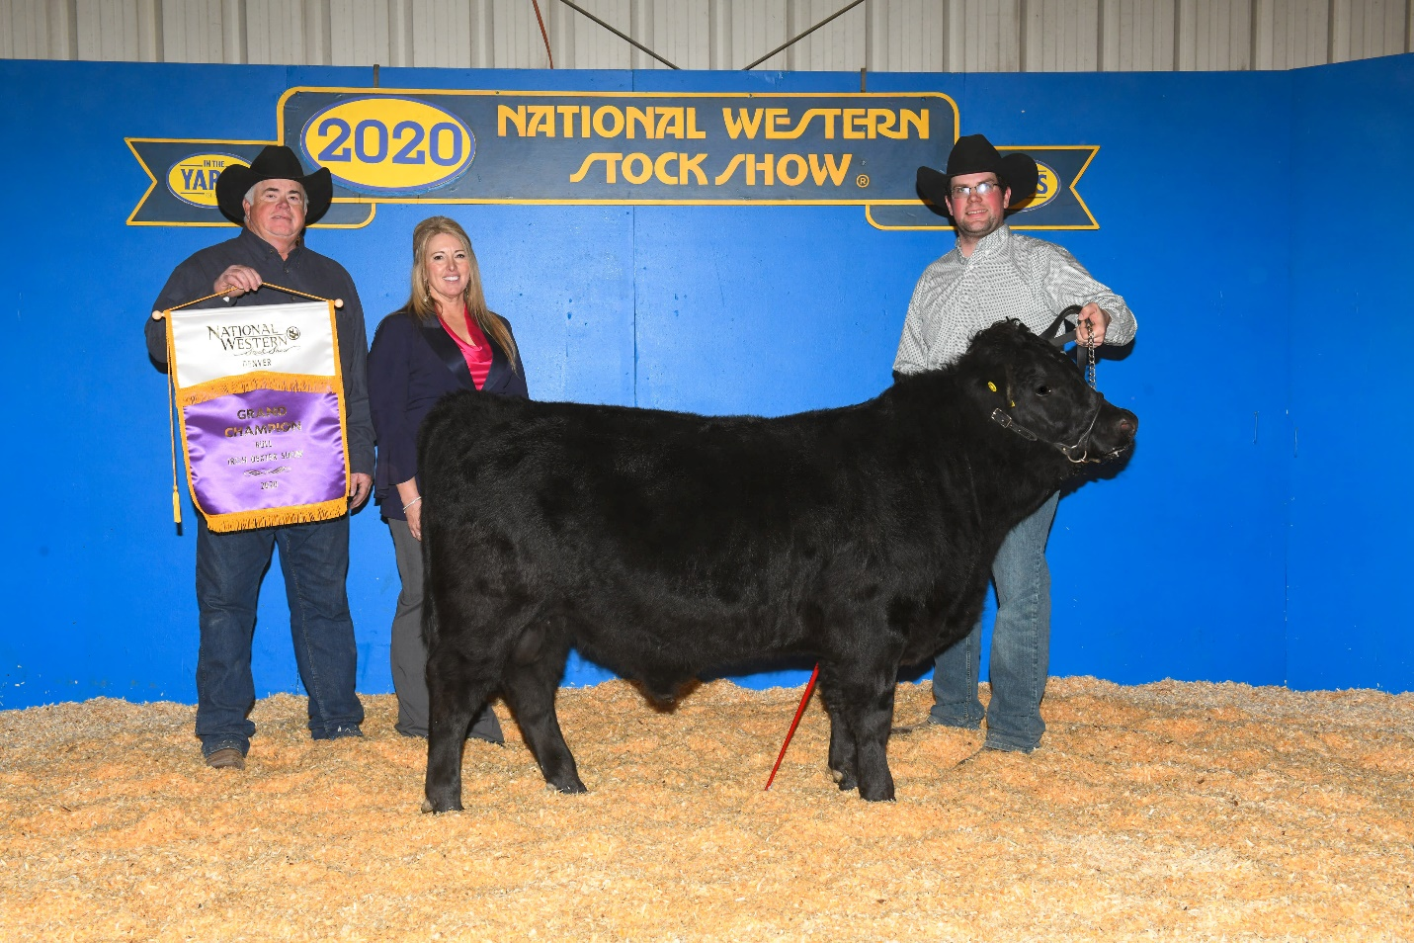
Place | Back# | Animal Name | Owner | Exhibitor
1st | 6519 | BW FedEx | Weston Berry - BW Dexters of Lehi, UT | Weston Berry - BW Dexters of Lehi, UT
2nd | 6524 | Phrisky Farms I Told U So | Robin Pittack - Phrisky Farms of Shelton, WA | Robin Pittack - Phrisky Farms of Shelton, WA

